Final ( 2019-2020)
01. A.
Explain the purpose of an instance variable. Differentiate between an instance variable and a class variable. (4 marks)
Sol^{n}:
An instance variable is a variable declared inside a class but outside any method, constructor, or block. Each object of the class has its own copy of the instance variable. It is used to store the state or attributes of an individual object.
Example:
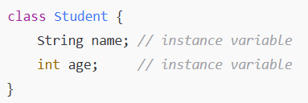
Feature | Instance Variable | Class Variable (Static Variable)
Belongs to | Each object of the class | The class itself, shared by all objects
Memory Allocation | Allocated in heap memory for each object | Allocated in static memory only once
Access | Accessed through object reference | Accessed through class name (or object)
Changes | Changes affect only the object instance | Changes affect all objects of the class
Declaration | Declared without static keyword | Declared with static keyword

01. B.
Explain the purpose of a method parameter. What is the difference between a parameter and an argument? Explain with an example. (4 marks)
Sol^{n}:
Already solve.
Example:
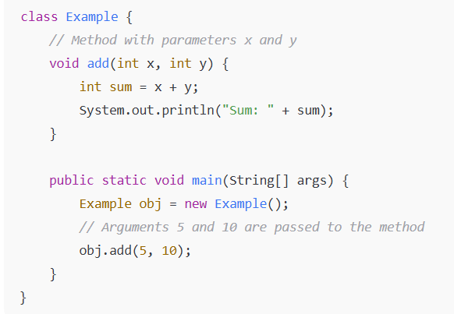
01. C.
Write a code that calculates and prints the sum of the integers from 1 to n. Use a while statement to loop through the calculation and increment statements. The loop should terminate when the value of x becomes n+1. (3 marks)
Sol^{n}:
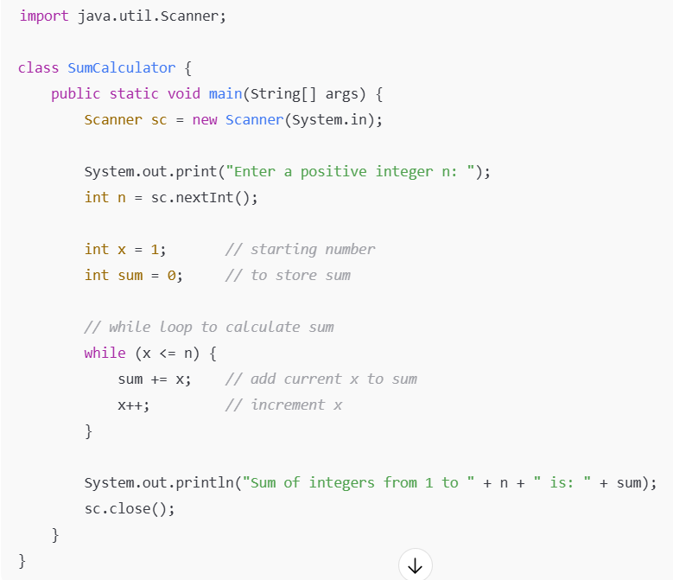

01. D.
i) Suppose x = 2 and y = 3. Show the output, if any, of the following code. What is the output if x = 3 and y = 2? What is the output if x = 3 and y = 3?
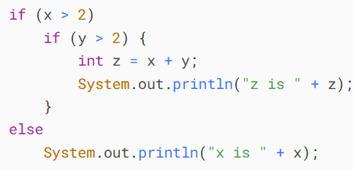
ii) What does the following code print?
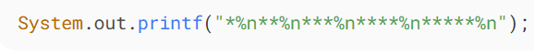

Sol^{n}:
i)
Important: In Java, else always pairs with the nearest unmatched if. So here, the else pairs with if (y > 2) — not if (x > 2).

Case 1: x = 2, y = 3
- if (x > 2) → 2 > 2 → false
- So the inner if and else are skipped.
- Output: Nothing
Case 2: x = 3, y = 2
- if (x > 2) → 3 > 2 → true → execute inner if
- if (y > 2) → 2 > 2 → false → go to else (paired with inner if)
- System.out.println("x is " + x); → prints x is 3
Case 3: x = 3, y = 3
- if (x > 2) → true → enter inner if
- if (y > 2) → 3 > 2 → true → calculate z = x + y = 6
- Print: z is 6
ii)
*
**
***
****
*****

02. A.
What type of repetition would be appropriate for calculating the sum of the first 100 positive integers? What type would be appropriate for calculating the sum of an arbitrary number of positive integers? Briefly describe how each of these tasks could be performed with an example. (4 marks)
Sol^{n}:
Sum of the first 100 positive integers is a Definite loop. We know exactly how many times to repeat, so we use for loop because we know how many time the code run.
Example:
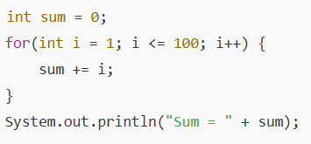
Sum of an arbitrary number of positive integers is a Indefinite loop. We do not know in advance how many numbers the user will enter. So we use for loop because we don’t know how many time the loop execute.
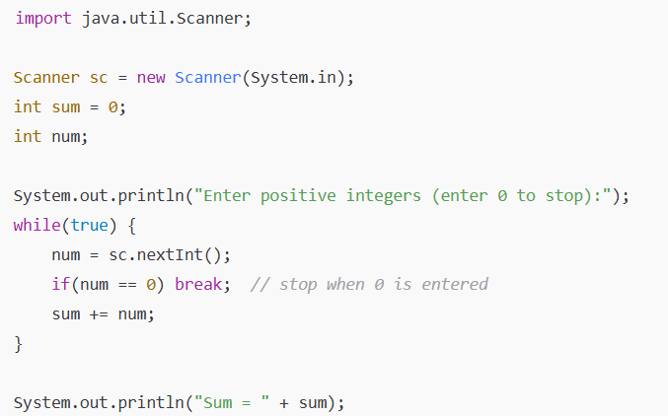

02. B.
Write a Java program to check if three given side lengths (integers) can make a triangle or not. (3 marks)
Sol^{n}:
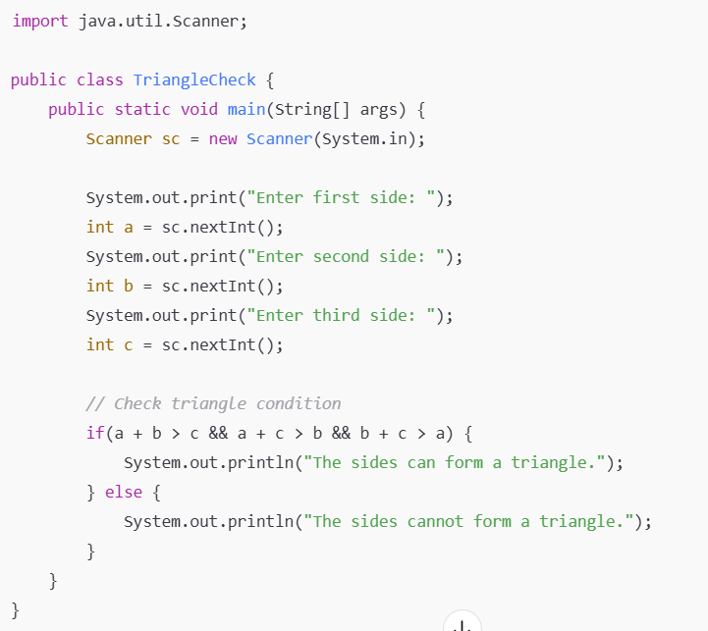

02. C.
i) What is y after the following switch statement is executed? Rewrite the code using an If-else statement.
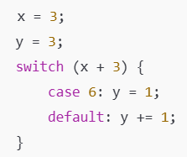
ii) Fill in the blanks in each of the following statements:
a) Typically, _________ statements are used for counter-controlled repetition and _________ statements for sentinel-controlled repetition.
b) The do-while statement tests the loop-continuation condition _________ executing the loop's body; therefore, the body always executes at least once.
c) The _________ statement selects among multiple actions based on the possible values of an integer variable or expression, or a String.
d) The _________ statement, when executed in a repetition statement, skips the remaining statements in the loop body and proceeds with the next iteration of the loop. (2+2 marks)

Sol^{n}:
i)
Step 1: Evaluate the switch expression
- x + 3 = 3 + 3 = 6
Step 2: Execute the matching case
- case 6: matches → y = 1;
- Important: There is no break, so execution falls through to default: → y += 1;
Step 3: Final value of y
- y = 1 (from case 6)
- y += 1 → y = 2
Answer: y = 2
Equivalent If-Else code:
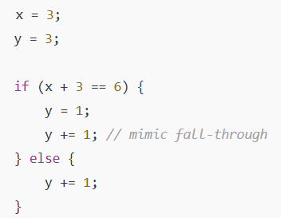
ii)
Fill in the blanks
a) Typically, for statements are used for counter-controlled repetition and while statements for sentinel-controlled repetition.
b) The do-while statement tests the loop-continuation condition after executing the loop's body; therefore, the body always executes at least once.
c) The switch statement selects among multiple actions based on the possible values of an integer variable or expression, or a String.
d) The continue statement, when executed in a repetition statement, skips the remaining statements in the loop body and proceeds with the next iteration of the loop.

02. D.
Write a program that prompts the user to enter a three-digit integer and determines whether it is a palindrome number. A number is palindrome if it reads the same from right to left and from left to right. Here is a sample run of this program: (3 marks)
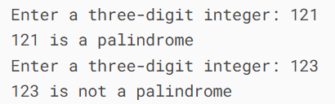

Sol^{n}:
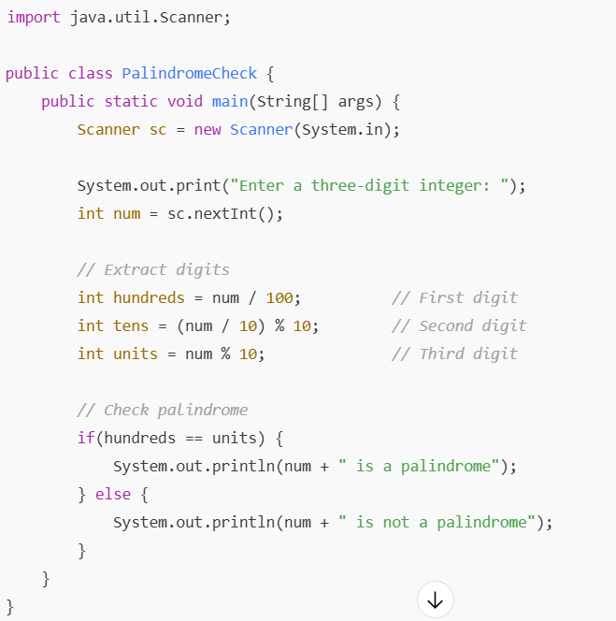

03. A.
Find the error in each of the following program segments. Explain how to correct the error. (4 marks)
a)
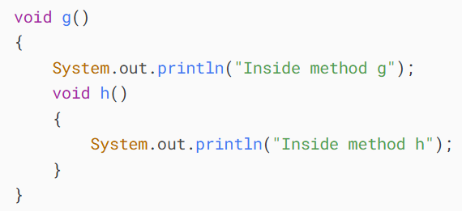
b)
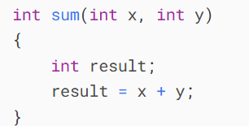
c)
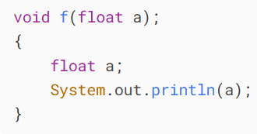
d)
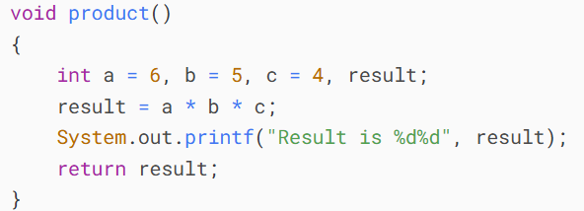
Sol^{n}:
a)
Error:
- In Java, you cannot define a method inside another method. The method h() is nested inside g(), which is illegal.
Correction:
- Define h() as a separate method, not inside g()
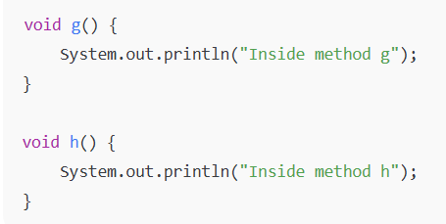
b)
Error:
- The method has a return type int, but there is no return statement. Java requires methods with non-void return types to return a value.
Correction:
- Add a return statement:
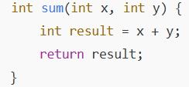
c)
Errors:
- The semicolon ; after the method header is incorrect. It should not be there.
- The parameter a is redeclared inside the method (float a;), which is illegal.
Correction:
- Remove the semicolon and the redeclaration of a:
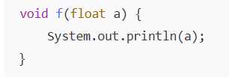
d)
Errors:
- The method is declared void but it returns an int (return result;).
- System.out.printf("Result is %d%d", result); has two format specifiers (%d%d) but only one argument (result).
Correction:
- Either make the method return int and fix the printf, or keep it void and just print the result. Here's one fix keeping void:
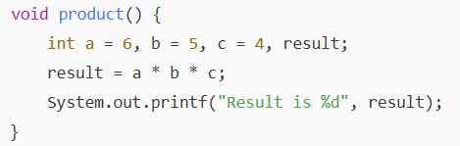
Or,
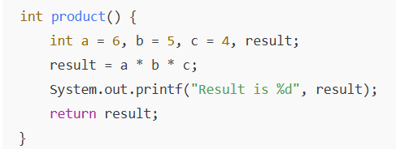

03. B.
A positive integer is prime if it's divisible by only 1 and itself. For example, 2, 3, 5 and 7 are prime, but 4, 6, 8 and 9 are not. The number 1, by definition, is not prime.
a) Write a method that determines whether a number is prime.
b) Use this method in an application that determines and displays all the prime numbers less than 10,000. How many numbers up to 10,000 do you have to test to ensure that you've found all the primes?
c) Initially, you might think that n/2 is the upper limit for which you must test to see whether a number n is prime, but you need only go as high as the square root of n. Rewrite the program, and run it both ways. (4 marks)
Sol^{n}:
Method to determine if a number is prime:
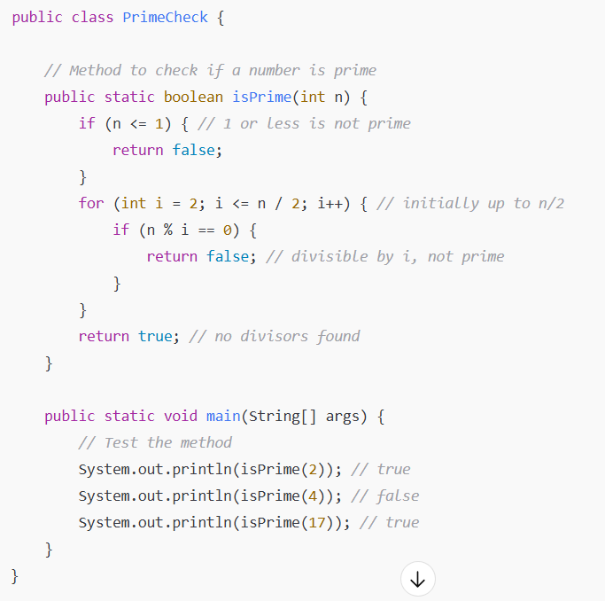
Display all primes less than 10,000:
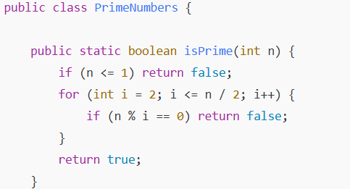
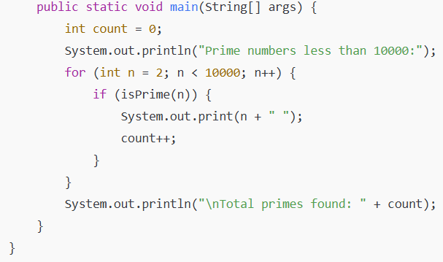
Optimize using square root:
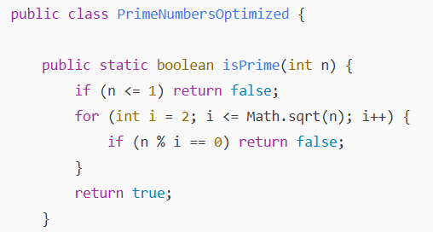
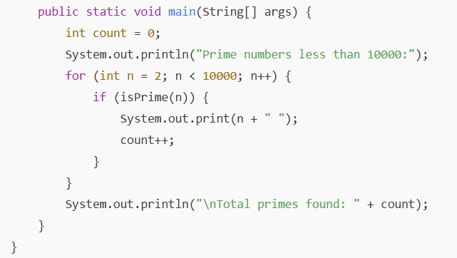

03. C.
Write an application that calculates the average of a series of integers that are passed to method average using a variable-length argument list. Test your method with several calls, each with a different number of arguments. (3 marks)
Sol^{n}:
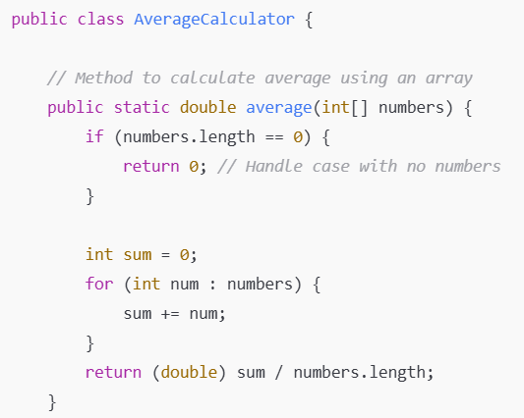
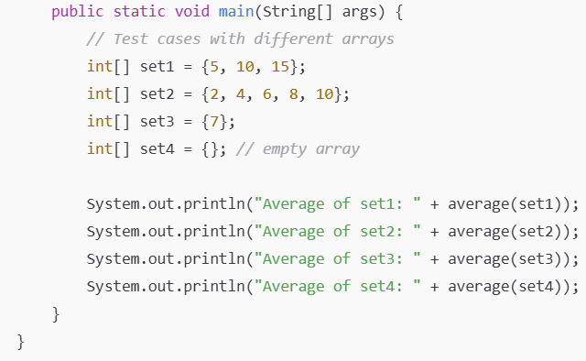

Rest of code after the mid term all course exam….

